North Georgia Master Gardener Extension Volunteer Program

Native Shrubs and Small Trees
Bottlebrush Buckeye (Aesculus parviflora): Part shade to full sun Red Buckeye (Aesculus pavia): Part shade to full sun Serviceberry (Amelanchier canadensis): Part shade to full sun Red Chokeberry (Aronia arbutifolia): Part sun to full sun Beautyberry (Callicarpa americana): Part sun to full sun

Beautyberry

Red Chokeberry

Buttonbush

Bottlebrush Buckeye
Sweetshrub (Calycanthus floridus): Shade to part sun
New Jersey Tea (Ceanothus americanus): Part sun to full sun Buttonbush (Cephalanthus occidentalis): Part sun to full sun Sweet Pepperbush (Clethra alnifolia): Part sun to full sun American Hazelnut (Corylus americana): Part shade to full sun Trailing Arbutus (Epigaea repens): Part shade to Part sun
Hearts-a-Bustin (Euonymus americanus): Part shade to part sun Fothergilla (Fothergilla gardenii): Part sun to full sun Witchhazel (Hamamelis virginiana): Shade to part sun
Oakleaf Hydrangea (Hydrangea quercifolia): Part shade to part sun Shrubby St.John’s Wort (Hypericum prolificum): Part sun to sun Inkberry (Ilex glabra): Part sun to full sun
Winterberry (Ilex verticillata): Part sun to full sun
Yaupon Holly (Ilex vomitoria): Part sun to full sun
Florida Anise Tree (Illicium floridanum): Part shade to part sun Virginia Sweetspire (Itea virginica): Shade to full sun Mountain Laurel (Kalmia latifolia): Part shade to part sun Spicebush (Lindera benzoin): Shade to part sun
Ninebark (Physocarpus opulifolius): Part to full sun
Native Azaleas (Rhododendron): Part shade to part sun
Rhododendron (Rhododendron maximum and R. minus): Part shade to part sun
Elderberry (Sambucus canadensis): Full sun
Highbush Blueberry (Vaccinium corymbosum): Part sun to full sun Arrowwood Viburnum (Viburnum dentatum): Part to full sun Witherod Viburnum (Viburnum cassinoides): Part to full sun Yellowroot (Xanthorhiza simplicissima): Shade to part sun
Yucca (Yucca filamentosa): Part to full sun

Elderberry

Shrubby St.John’s Wort

New Jersey Tea

Oakleaf Hydrangea



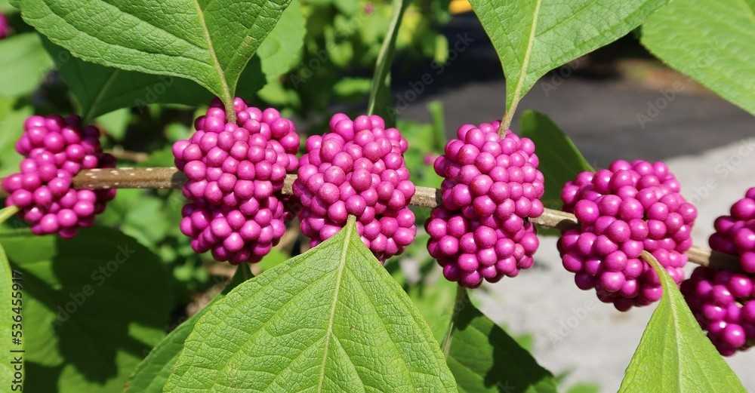


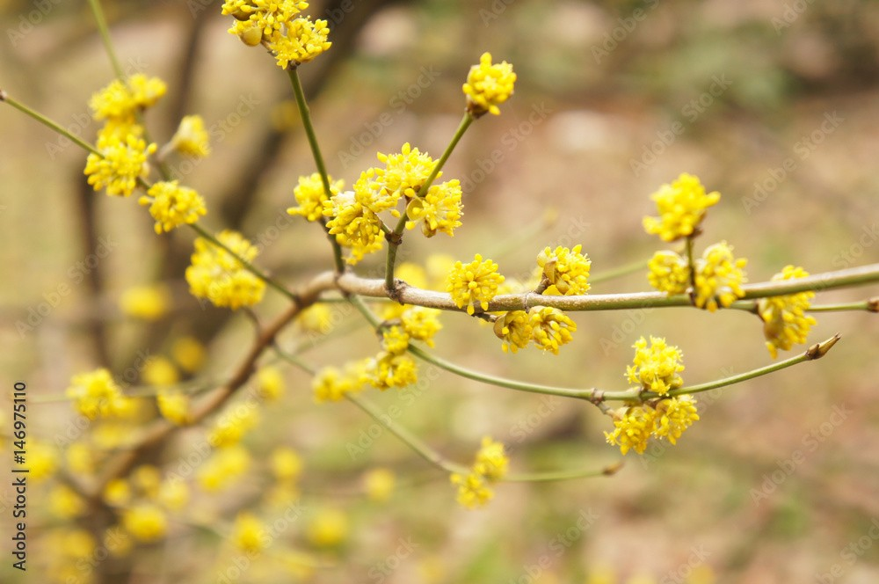

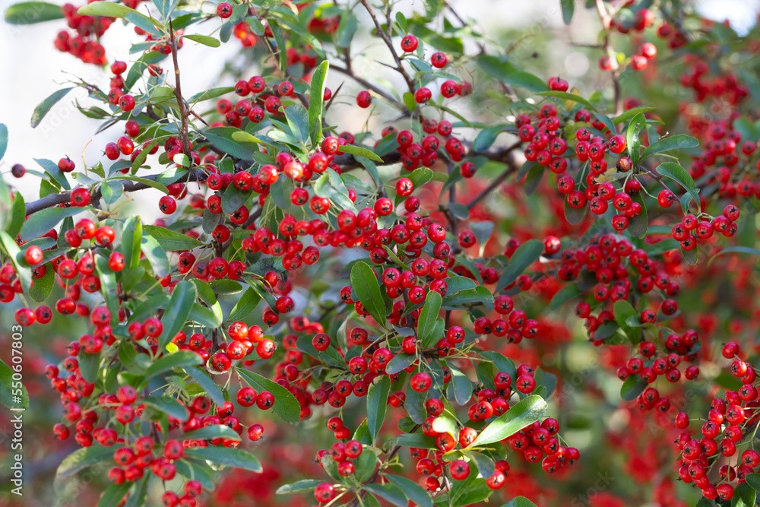

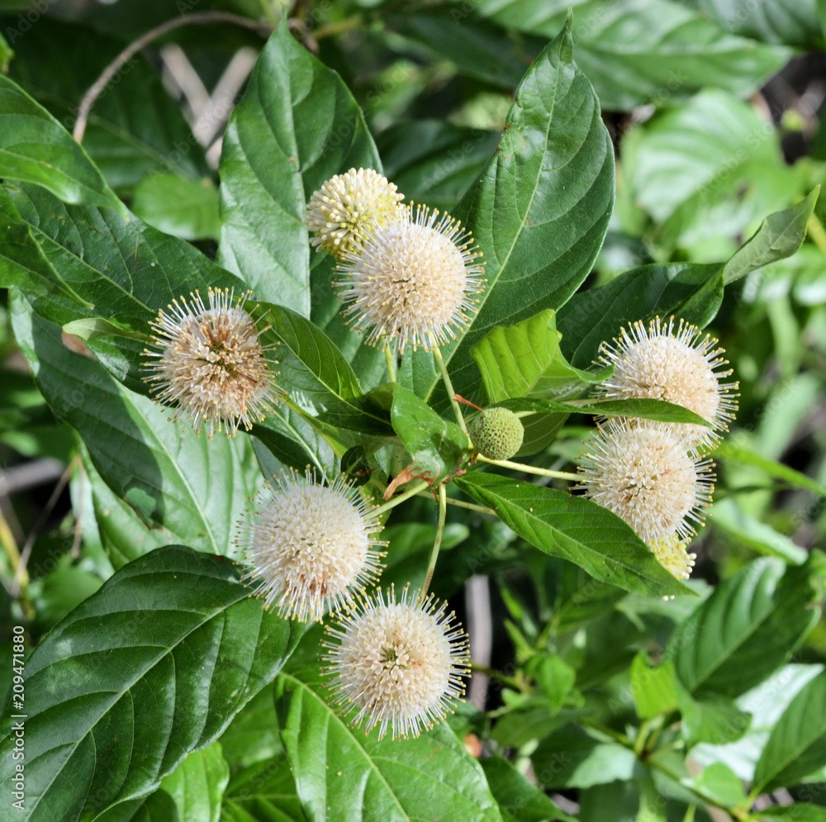
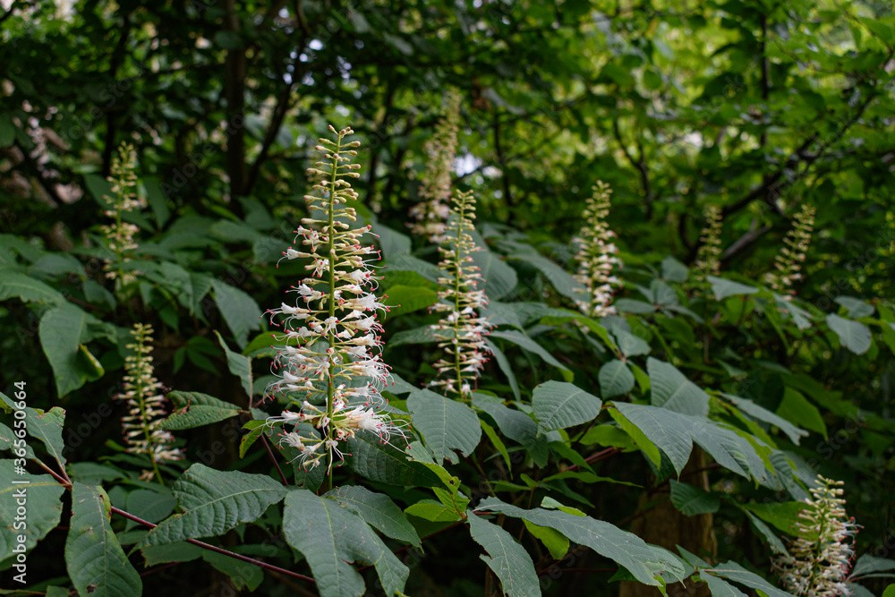


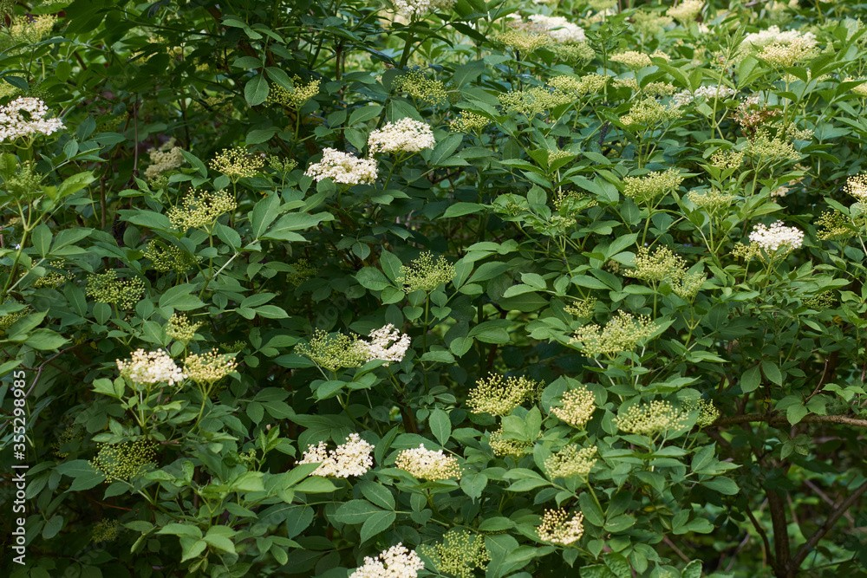
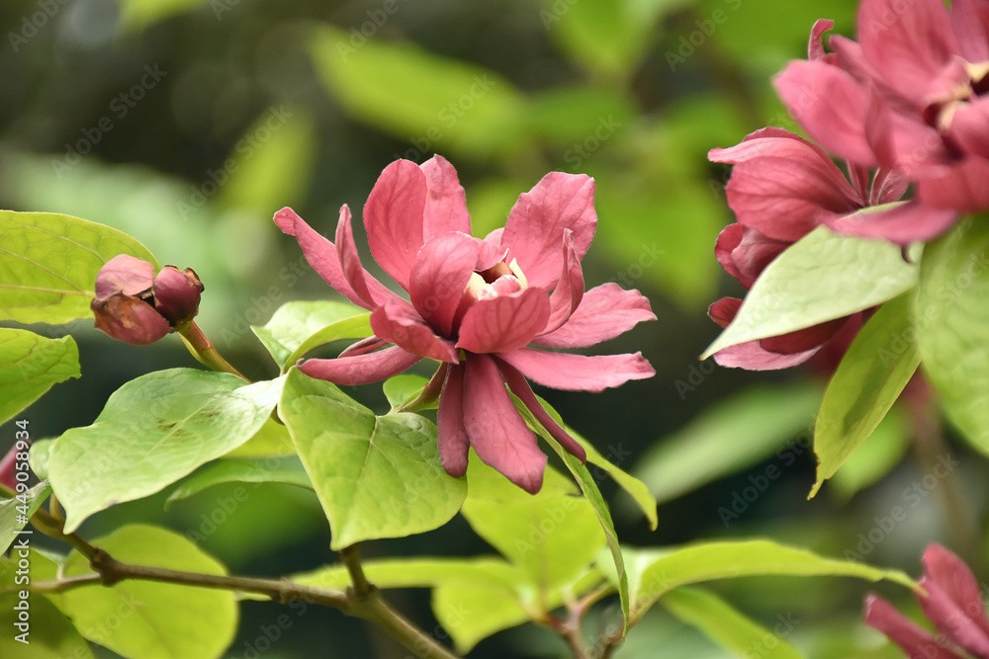

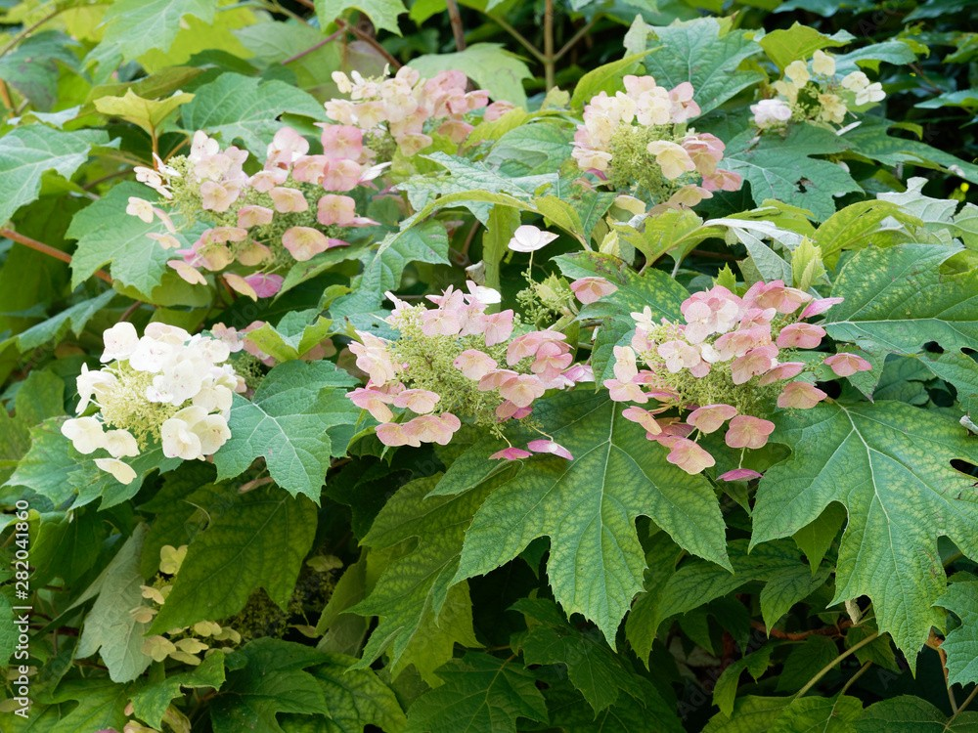

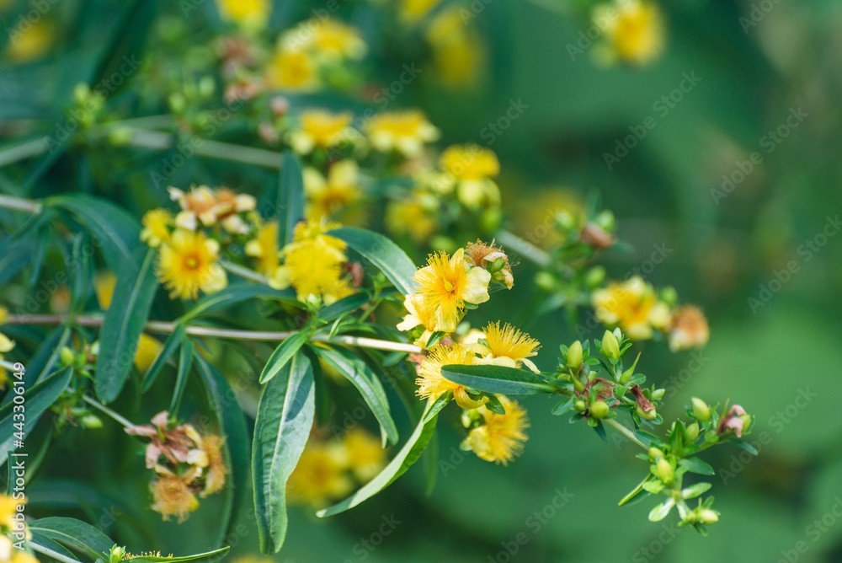

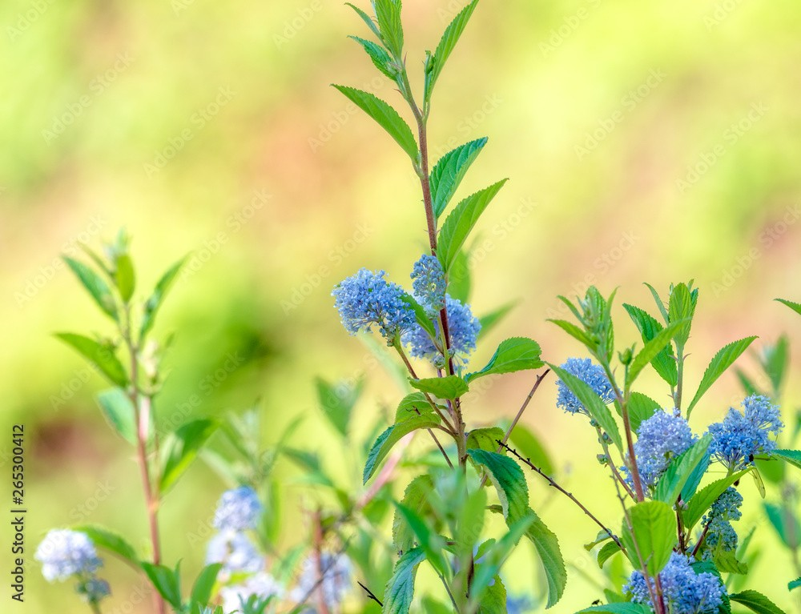
Spicebush
An Equal Opportunity, Affirmative Action, Veteran, Disability Institution
Sweetshrub

