North Georgia Master Gardener Extension Volunteer Program

Native Wildflowers and Perennials

Butterfly Weed

Columbine

Hardy Ageratum

Coreopsis
Eastern Monkshood (Aconitum uncinatum): Part shade to part sun
Black Cohosh (Actaea racemosa): Part shade to part sun
White Snakeroot (Ageratina altissima): Part shade to part sun
Arkansas Bluestar (Amsonia hubrichtii): Full sun to part shade
Wood Anemone (Anemone quinquefolia): Shade to part shade
Thimbleweed (Anemone virginiana): Part shade to part sun
Columbine (Aquilegia canadensis): Part shade to part sun
Jack-in-the-Pulpit (Arisaema triphyllum): Part shade Goat’s Beard (Aruncus dioicus): Part shade to part sun
Wild Ginger (Asarum canadense): Shade to part sun Butterfly Weed (Asclepias tuberosa): Part to full sun Wild Indigo (Baptisia species, white, blue, yellow): Full sun
Doll’s Daisy (Boltonia asteroides): Part shade to sun American Bellflower (Campanula americana): Part sun to sun
Toothwort (Cardamine diphylla): Shade to part sun Fairy-Wand (Chamaelirium luteum): Part shade to part sun
Turtlehead (Chelone several species): Part sun to sun Green and Gold (Chrysogonum virginianum): Shade to part sun
Spring Beauty (Claytonia virginica): Shade to part sun Hardy Ageratum (Conoclinium coelestinum): Part to full sun
Coreopsis (Coreopsis several species): Part shade to sun
Dwarf Spiderwort (Tradescantia rosea): Part shade to part sun
Pink Lady’s Slipper (Cypripedium acaule): Part shade to part sun
Larkspur (Delphinium tricorne): Part shade to sun Bleeding Heart (Dicentra eximia and D. canadensis): Part shade to part sun
Shooting Star (Dodecatheon meadia): Part shade to part

Purple Coneflower (Echinacea purpurea): Full sun
Sundrops (Oenothera fruticosa): Full sun
Soapwort Gentian (Gentiana saponaria): Part shade to part sun
Wild Geranium (Geranium maculatum): Part shade to part sun
Indian Physic (Gillenia trifoliata): Part sun to full sun Dogtooth Daisy (Helenium autumnale): Full sun Swamp Sunflower (Helianthus angustifolius): Full sun Smooth Oxeye or Oxeye Sunflower (Heliopsis helianthoides): Full sun
Hepatica (Hepatica americana): Shade to part shade Alumroot (Heuchera americana): Part shade to part sun

Heartleaf Ginger, “Little Piggies” (Hexastylis arifolia):

Shade to part shade
Scarlet Hibiscus (Hibiscus coccineus): Part sun to full sun
Rose Mallow (Hibiscus moscheutos): Part sun to full sun
Spiderlily (Hymenocallis occidentalis): Part shade to part sun
Yellow Stargrass (Hypoxis hirsuta): Part shade to part sun
Orange Jewelweed (Impatiens capensis): Shade to part sun
Dwarf Crested Iris (Iris cristata): Shade to part shade Gayfeather or Blazing Star (Liatris spicata): Full sun Carolina Lily (Lilium michauxii): Part shade to part sun Turks-cap Lily (Lilium superbum): Part shade to part sun
Cardinal Flower (Lobelia cardinalis): Part shade to full sun

Solomon’s Plume (Maianthemum racemosum):

Shade to part sun
Virginia Bluebells (Mertensia virginica): Shade to part shade
Partridgeberry (Mitchella repens): Shade to part sun Bee Balm (Monarda didyma): Part sun to full sun Allegheny Spurge (Pachysandra procumbens): Shade to part sun
Beardtongue (Penstemon smallii): Part sun to full sun Fernleaf Phacelia (Phacelia bipinnatifida): Shade to part sun
White Wood Aster (Eurybia divaricata): Part shade to part sun
Hollow Joe-Pye Weed (Eutrochium fistulosum): Part sun to full sun

Wild Geranium

Spiderlily

Rose Mallow

Virginia Bluebells





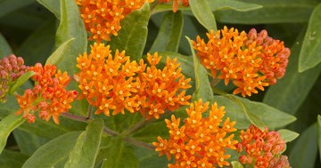

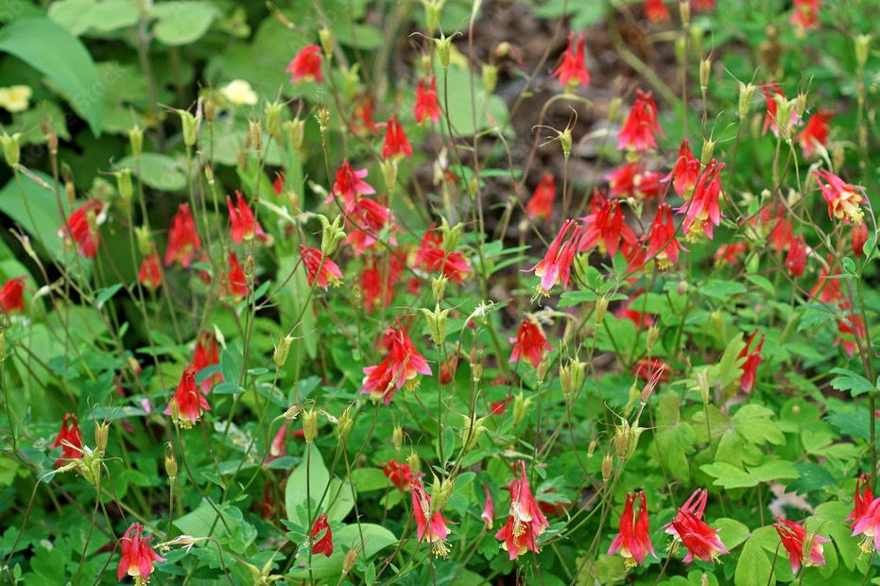

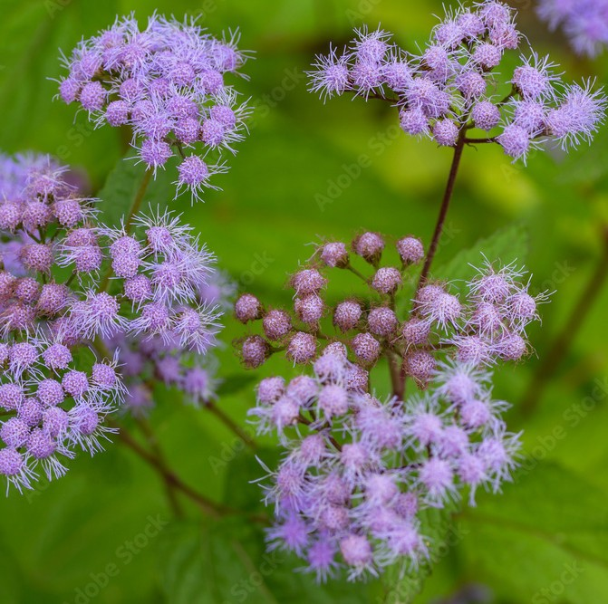

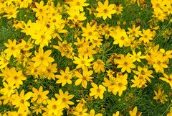

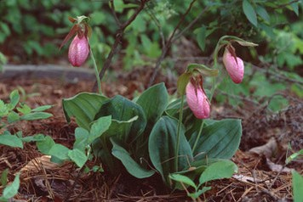

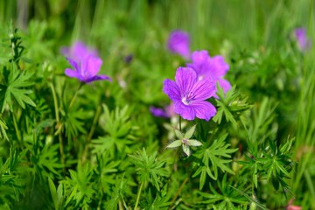

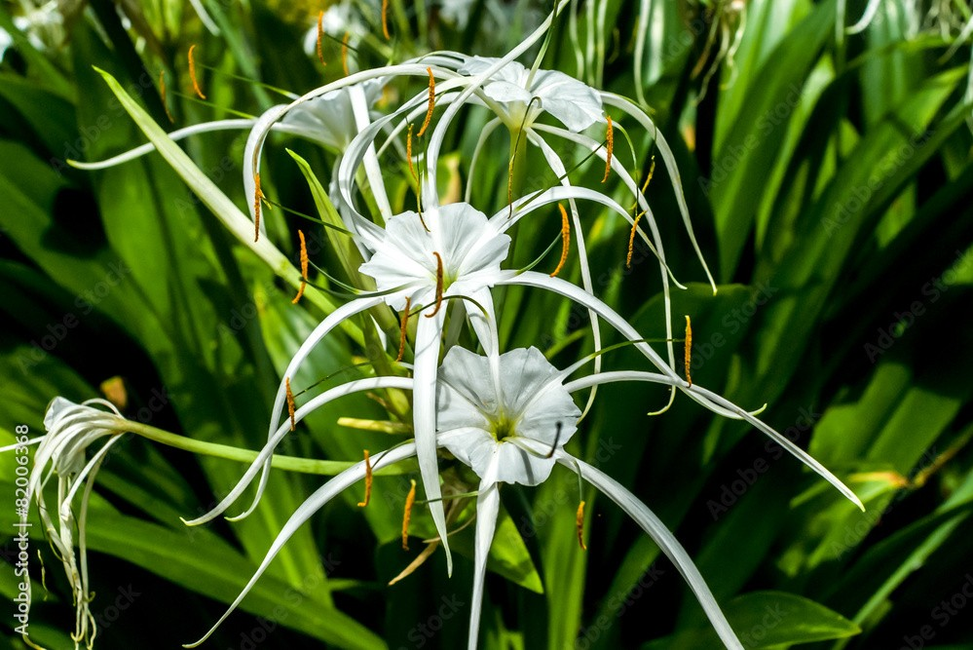

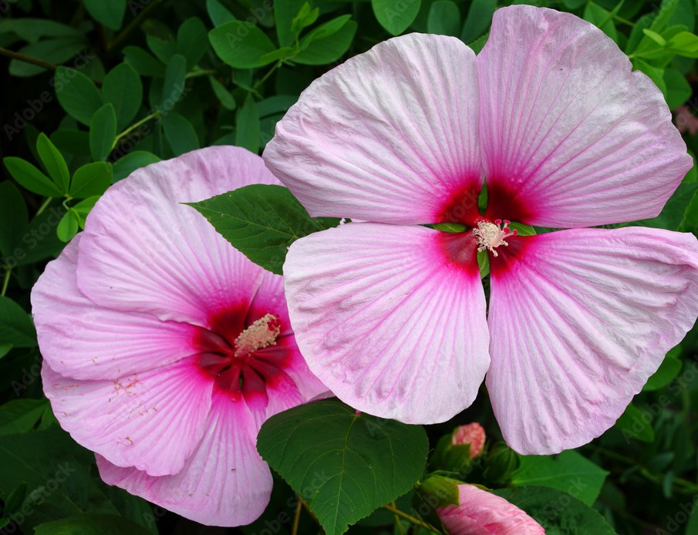

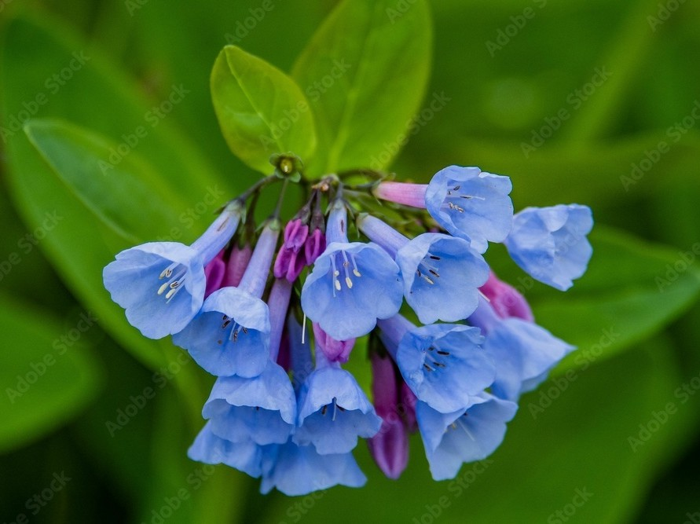

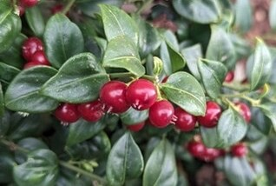
Pink Lady’s Slipper
An Equal Opportunity, Affirmative Action, Veteran, Disability Institution
Partridgeberry

North Georgia Master Gardener Extension Volunteer Program

Native Wildflower and Perennials

Woodland Phlox

Scarlet Sage

Mountain Mint

Celandine Poppy

Blanket Flower (Gaillardia pulchella): Full sun
Galax (Galax aphylla): Shade to part sun
Wintergreen (Gaultheria procumbens): Shade to part shade

Gaura (Gaura biennis or Oenothera gaura): Full sun
Dimpled Trout Lily (Erythronium umbilicatum): Shade to part sun

Carolina Phlox (Phlox Carolina): Full sun
Woodland Phlox (Phlox divaricata): Shade to part sun Obedient Plant (Physostegia virginiana): Part sun to full sun Mayapple (Podophyllum peltatum): Shade to part shade Jacob’s Ladder (Polemonium reptans): Shades to part shade Solomon’s Seal (Polygonatum biflorum): Shade to part sun Mountain Mint (Pycnanthemum incanum): Part shade to sun Orange Coneflower (Rudbeckia fulgida): Full sun

Scarlet Sage (Salvia coccinea): Full sun
Bloodroot (Sanguinaria canadensis): Shade to part shade Downy Skullcap (Scutellaria incana): Part sun to full sun Mountain Stonecrop (Sedum ternatum): Shade to part sun Fire Pink (Silene virginica): Part sun to full sun
Blue-eyed Grass (Sisyrinchium angustifolium): Part sun to full sun
Goldenrod (Solidago varieties): Part sun to full sun Indian Pink (Spigelia marilandica): Part shade to part sun Giant Chickweed (Stellaria pubera): Shade to part shade Stokes Aster (Stokesia laevis): Part sun to full sun
Celandine Poppy (Stylophorum diphyllum): Shade to part sun Rue Anemone (Thalictrum thalictroides): Shade to part shade Carolina False Lupine (Thermopsis villosa): Full sun Foamflower (Tiarella wherryi): Shade to part sun
Ohio Spiderwort (Tradescantia ohiensis): Shade to part sun
Trillium (Trillium various): Shade to part shade Bellwort (Uvularia grandiflora): Shade to part sun Ironweed (Vernonia noveboracensis): Full sun Violets (Viola various): Part sun to full sun
Atamasco Lily (Zephyranthes atamasca): Shade to sun
Golden Alexander (Zizia aurea): Part shade to part sun

Indian Pink

Dimpled Trout Lily

Stokes Aster

Rue Anemone


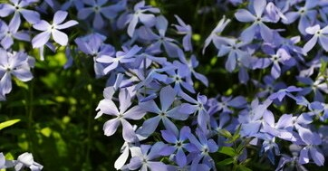

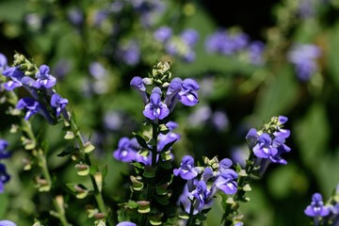

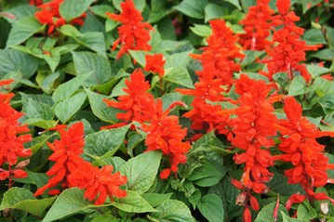

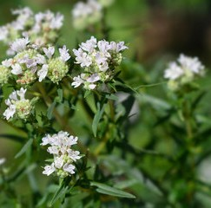

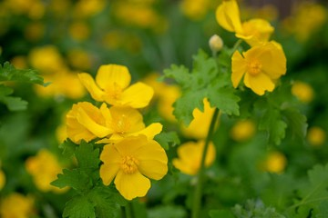
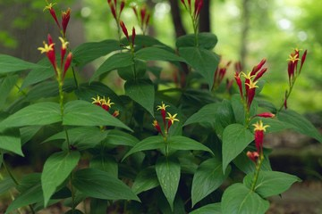

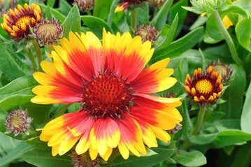
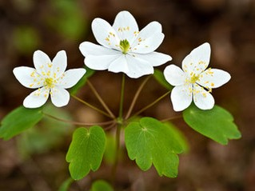

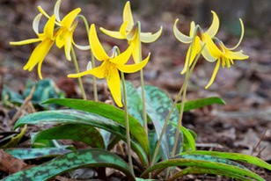
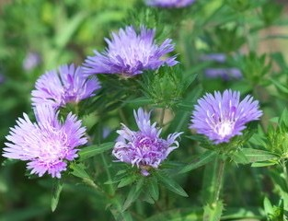

Downy Skullcap

An Equal Opportunity, Affirmative Action, Veteran, Disability Institution

Blanket Flower

