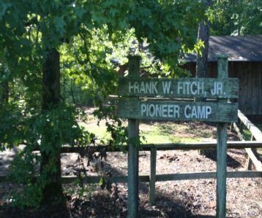
Georgia 4-H
Senior Extreme Camp
June 8-12, 2020
Frank Fitch Pioneer Camp
Rock Eagle 4-H Center

It’s an exciting camp just for Senior 4-H’ers! It’s your chance to enjoy a week in the great outdoors! Senior Extreme Camp will include: your choice of six zip lines or kayaking the Broad River, archery, shotguns, .22’s, canoes, low ropes, herpetology, and the annual Gilligan’s Island competition! We’ll hike the trails at Rock Eagle, run milk with the Counselors, attend the Counselor Variety Show, participate in the Rock Eagle Pageant, and more! We’ll also cook meals on the grill and spend the night outdoors in tents or Enos at Pioneer Camp.
OPTIONAL TRIP: Whitewater Rafting the Ocoee River! You’ll arrive on Sunday, June 7, 2020. We’ll travel to Wahsega 4-H Center to spend the night, raft the Ocoee River on Monday morning, then join everyone back at camp Monday evening! For additional $75.00

If you are an outdoors person who likes shooting, fishing, climbing, camping, and roughing it, then Senior Extreme Camp is for you! Contact your local 4-H Office for all the details! Hurry, we only have room for 50 campers!

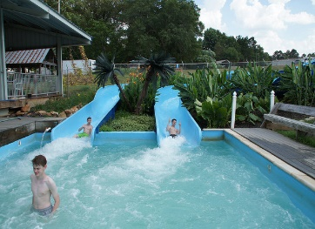
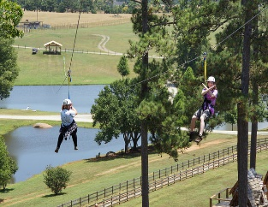
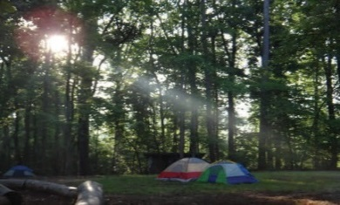
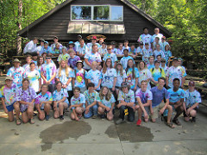
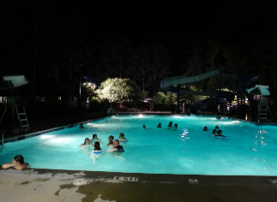
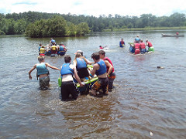
To see pictures from previous year’s Extreme Camps, visit https://flic.kr/s/aHskebqUWE, https://flic.kr/s/aHsjYWMAzL, https://flic.kr/s/aHskC48HUC, or https://flic.kr/s/aHsm3axES7.
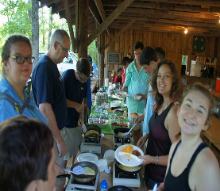

Chatham County 4-H
17 Minus Ave
Garden City, GA 31408
912-652-7981 or sgabel@uga.edu
Cost$370.00 Transportation not provided to camp
$75.00 Deposit required, balance due May 11, 2020

