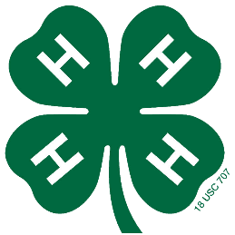

It’s a Rally at the Falls!!!
2024 NE & NW District Junior Rally

Attention all Northeast/Northwest District 6th - 8th Grade 4-H Members!!! You are invited to the Northeast/Northwest District 4-H Junior Rally on April 22 - 23, 2023 at Wahsega 4-H Center!
We are so excited to invite you to this event! It is going to be a blast! We hope you will join us! Here are the details:

What: 2024 Northeast/Northwest District Junior Rally

Who: All 6th – 8th Grade Northeast & Northwest District 4-H’ers

When: Saturday and Sunday, April 20 - 21, 2024

Where: Camp Wahsega 4-H Center

Cost: $ 40.00 (Includes registration, transportation, & insurance)

Registration Deadline:

What’s Planned
We’ll have exciting things to do like your choice of ropes course obstacles, talent show, dancing, campfire, s’mores, other interesting classes, community service projects, time in the falls (weather permitting), the annual glow-in-the-dark night Easter Egg Hunt, plus plenty of time to hang out with all your friends from Northeast and Northwest Districts!

For more information, please call the Extension Office at: XXX-XXX-XXXX. If you are interested in attending, please fill out the registration below and bring it and $00.00 to the Extension Office by: _______ __, 2024.

The University of Georgia College of Agricultural and Environmental Sciences (working cooperatively with Fort Valley State University, the U.S. Department of Agriculture, and the counties of Georgia) offers its educational programs, assistance, and materials to all people without regard to race, color, religion, sex, national origin, disability, gender identity, sexual orientation or protected veteran status and is an Equal Opportunity, Affirmative Action organization.

2024 Northeast/Northwest District 4-H Junior Rally Registration

Name:________________________________________________________________

Address:______________________________________________________________

Grade:________ Age:________ Sex:_________ Race:_________(For reporting purposes.)

