HEADPHONES
Georgia 4-H Consumer Judging
2015

Headphones allow the user to listen to a variety of different sounds, including music and audio recordings. There are many different types of headphones, ranging in price, style and comfort. When selecting a pair of headphones, the consumer should pick a style that best meets their needs and is in his/her price range. There are several types of headphones and features to consider in making this decision.

Main Types of Headphones
Type | Description | Best Uses | Price Range
Over-Ear/Full-Size  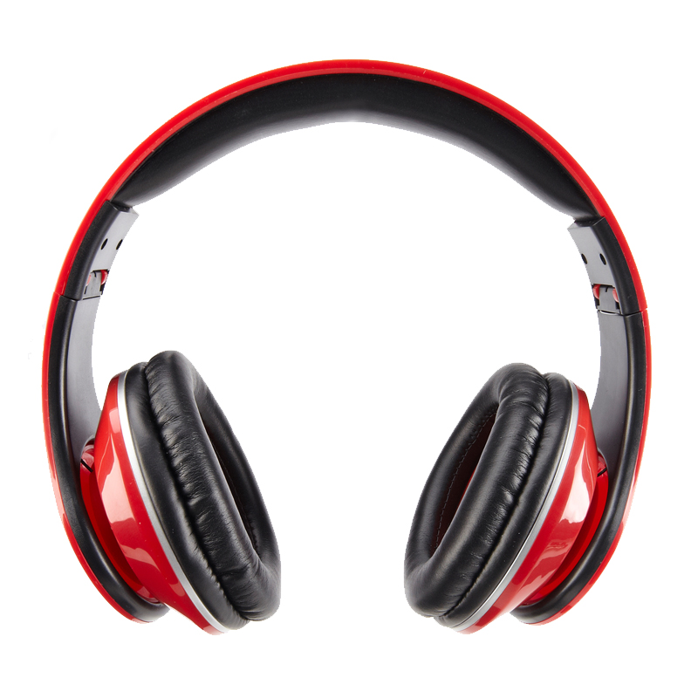 | These are traditional-looking headphones with large ear cups and cushioned pads that cover the whole ear. Full-Size headphones are bulkier, but generally very comfortable because of generous padding and design that helps prevent stress or injury. Cancel out ambient noise. | Home or Office | $40-$300
On-Ear / Lightweight  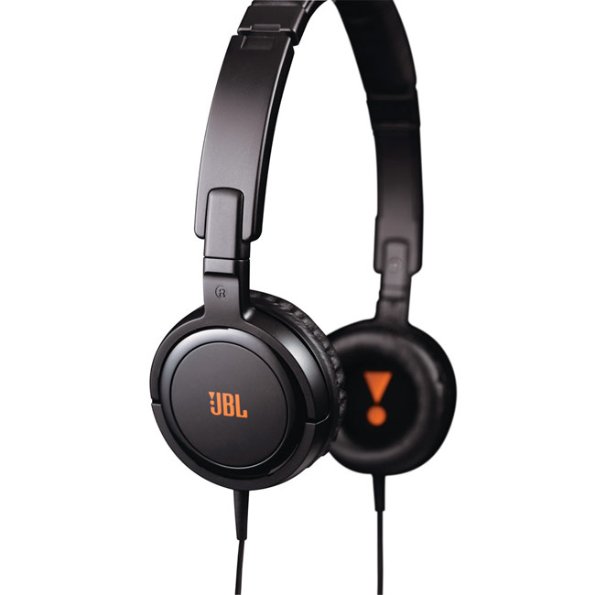 | These are headphones which sit or rest on the ears rather than over them. They typically have a thin headband that goes over or behind the head. Some other models use small clips that slip over your ear. They allow more ambient sound to reach the listeners ears. | Exercising; Travel | $20-$130
In-Ear /Canal-phones  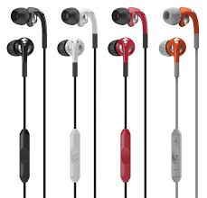 | These headphones rest in the ear canals. There are capable of producing incredible audio quality. For optimal use, they fit snugly and create a seal, similar to the effect of standard earplugs. They can be custom made in order to fit your ear canal. | Noisy Environments; Travel | $75-$420
Canal Buds  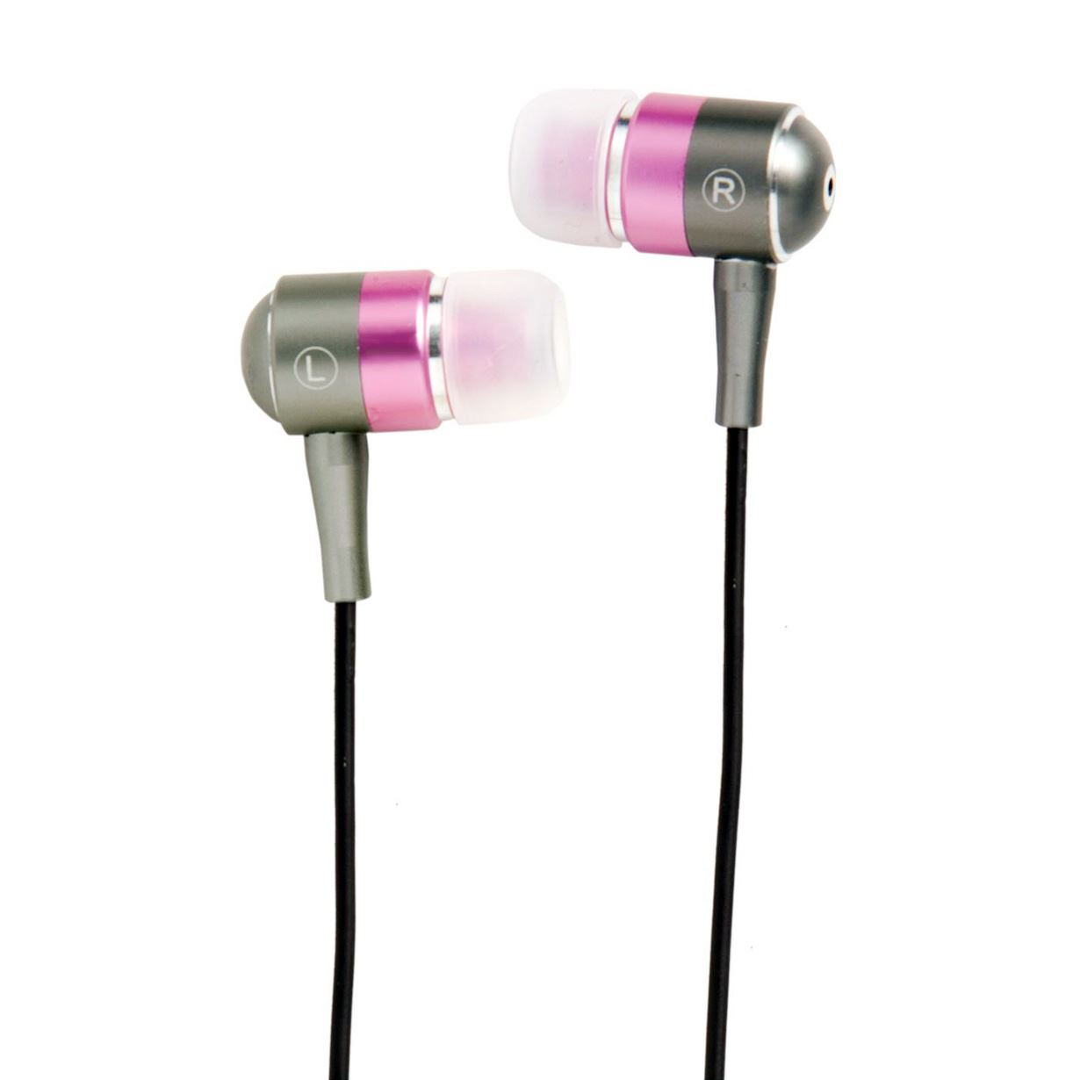 | Canal buds are the middle ground between earbuds and in-ear canal. They sit just on the inside of your ear instead of deep inside. They tend to be more comfortable because they are not as tightly fitting as the inner-ear canal and are generally less expensive. | On the Go | $49-$100
Earbuds  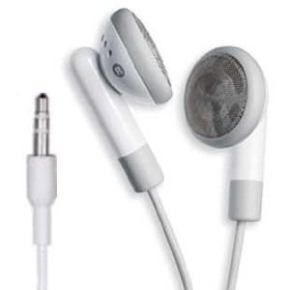 | Similar in size to in-ear headphones, earbuds are handy for listening to music while on the move. They sit outside the ear canal and don't fully seal your ear, meaning they are susceptible to sound leakage. They are generally the least expensive choice. | On the Go | $5-$90

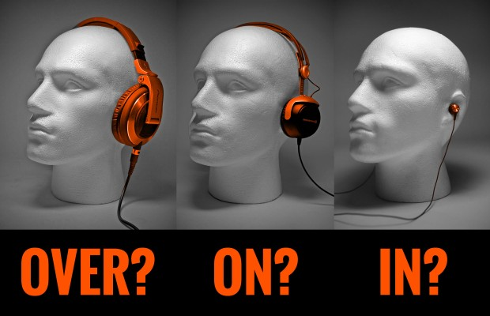

Other Types of Headphones
In addition to the main headphone types, there are other specialized types available for specific purposes. Here are some examples:
Type | Description | Best Uses | Price Range
Sports Headphones 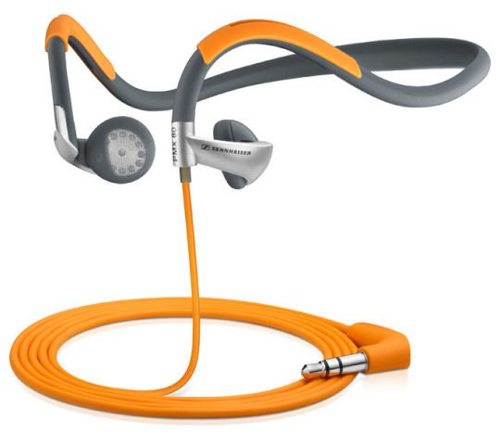 | Ideal for exercising built to withstand the rigors of any workout; built for comfort and portability; designed to be water and sweat resistant. | Working out; running; any type of exercise | $10-$380
Monitor Headphones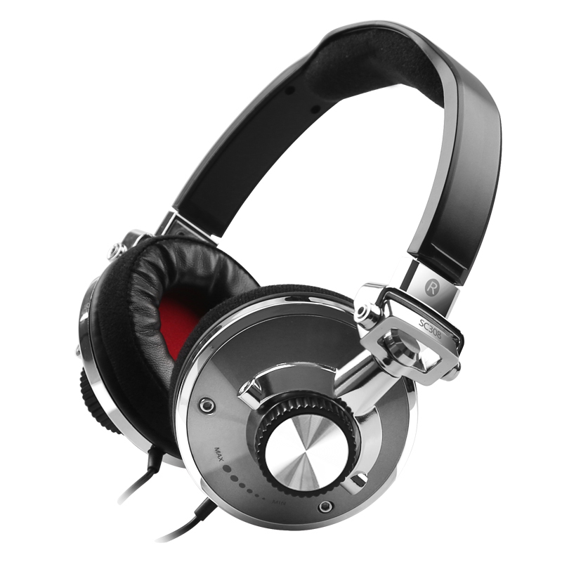 | Studio monitoring headphones; specialist headphone, designed to be used by audio professionals, where accurate sounds produced are crucial. | Sound engineering | $20-$2500

Open Versus Closed
Both the on-ear and in-ear headphones can also differ by the type of ear cups used. The ear
cup variations create different listening conditions and the headphone type that is right for you is purely personal preference. Both designs have their pros and cons and it usually comes down to personal preference as to which ones to buy. It is a good idea to try each type out in- store before buying.
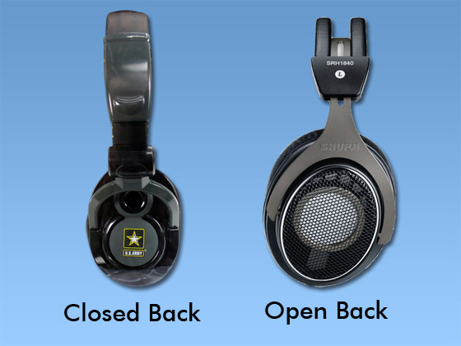

Open Back | Open is when the back of the ear pads are not completely sealed off. This can provide a more natural sound but open-back headphones tend to leak more ambient noise.
Closed Back | Closed is when the back of the ear pads are completely sealed off. They physically block out environmental noise. They can sound a bit muffled, but are good at preventing sound leakage and blocking out unwanted noise.

Special Features

Cables: Not all headphones use the same cables. Earbuds have a “Y” shaped cable that connects to each earpiece. Most stereo headphones have only one cable, connected to the left earpiece. The cable should be long enough to reach the device and allow freedom of move-ment. Extension cables and cable wraps can be purchased to extend or shorten the length of the cable. The plug itself will come in one of two types: the I-plug and the L-plug. The L-plug is especially useful if the audio jack is located on the side or bottom of the listening device.

Noise Cancelling Headphones: Noise cancelling headphones or noise reduction block outside sound keeping out all monotonous or routine noise that is not your audio tuner. They tend to be good at eliminating unwanted low-frequency noise such as traffic. They use an active noise control system, which means a power source is required. When turned on, noise-cancelling headphones emit a specific wave of sound, or “anti-noise,” that reduces the volume and essentially cancels out ambient noise. This feature is mainly available with the on- or over-ear headphones but some in-ear models have it as well. They are best suited for blocking low-frequency sounds.

Noise Isolation Headphones: Not to be confused with noise cancelling headphones, noise isolation headphones or earphones block outside sound by sealing in the ear when fitted. Some earphone models do look very similar to standard earbuds but have better audio quality. Noise isolation is the passive noise control created by closed headphones. These headphones are built with noise-insulating materials, padding, or mufflers rather than a power source. Passive noise controls become more effective at higher frequencies.

Built-In Controls: Many headphones offer built-in controls (also called in-line controls) that are convenient for listening on the go. These controls usually include play/pause and volume up/down. Bluetooth headsets connect with your smartphone and have buttons that allow you to easily switch between hands-free calling and listening to music.

Wireless Headphones: Wireless sets allow you to listen to music without being tethered to the audio source. They use radio frequencies to transmit sound from their base station to your ears. Long-range wireless connections such as FM systems allow you to move from room to room or even outside. The downside is you might experience interference. These are great for portable use.

Bluetooth Headphones: Bluetooth is a type of short-range wireless technology commonly used with hands-free mobile phone kits. Since most smartphones today are Bluetooth compatible, Bluetooth headphones make it easy to listen to music on the go. Today it is the most common format for transmitting wireless music. These headphones can double as headsets letting the consumer switch between music and voice features. They work at a distance of up to 10 meters, or 32 feet, from the receiver. However, the technology requires the compression of audio files, with results in a somewhat lesser quality sound. Bluetooth headphones consume a significant amount of battery life, especially compared to most other headphones, which don’t require batteries at all.

Headphone Controls: Some headphones come with controls built into the cable or earpiece. Typical controls include playback functions such as play/pause and volume up/down. Others include mobile phone functionality, enabling the user to seamlessly switch between hands-free telephone calls and listening to music.

Terms to Know
-Decibels (dB) is the unit for measuring sound. Decibels are used to indicate maximum SPL, which is how loud the headphones can get.
-The Ear Cup is the portion of the headphones that is placed over the ear and houses the speaker.
-Ear Cushions are the portion on the inside of the headphone ear cup that rests on your skin and around your ears.
-Frequency Response is the range of frequencies , in kHz, that drivers are able to reproduce before a significant drop in the volume level.
-A Headphone Amplifier is an electronic device that is designed to drive headphones rather than speakers. A dedicated headphone amplifier can provide better dynamic range, clarity and volume when driving headphones that the often cheap headphone output circuits on consumer electronics equipment.
-The headphone plug or jack is the part that plugs into the sound source. The standard conductor size for headphones is 3.5mm. Some older stereos require a ¼” plug, which is larger than the standard size of 1/8”.
-Impedance is the amount of opposition (or resistance) the headphone gives to the signal from the audio source. (The larger the impedance, the quieter the headphones will sound for a given volume level from the source. In contrast, a set of headphones with low impedance will sound louder.)
-Maximum SPL is the measure of how loud your headphones can get, indicated in decibels.
-Noise-induced hearing loss (NIHL) is the exposure to harmful noise/sounds that are too loud or loud sounds that last a long time causing sensitive structures in the inner ear to be damaged. The severity of hearing loss depends on the length and volume of exposure, and whether or not the user was wearing protection such as earplugs.
-A plug adapter is an attachment that slips over the plug, making it useful with more sound sources. An adapter can convert a 1/8” plug to a ¼” plug or vice versa. Most headphones come with a 1/4” and a 1/8” plug which eliminates the need of an adapter.
-Safe Hearing Levels: In general, sounds above 85dB are harmful, depending on how long and how often you are exposed to them and whether you wear hearing protection, such as earplugs or earmuffs. (Average home noise is 40 dB and normal conversation is 60 dB.)
-Sound leakage is the ability of unwanted sound to flow in or outside of the headphones.
-The term stereo designates headphones that play distinct sounds in each ear. They differ from mono headphones, which produce the exact same sounds in each ear.

Acknowledgements:
-Selecting Headphones – Connie Cecil, 4-H Youth Development Specialist, Colorado State University and Mindy Turner , 4-H Youth Development Specialist, New Mexico State University.
-Erin Rice, UGA Student

Compiled by Cheryl Varnadoe, Extension 4-H Specialist, University of Georgia, 2015.

